The following flowchart shows the three possible outcomes from a flexible working request. These steps are also described below.
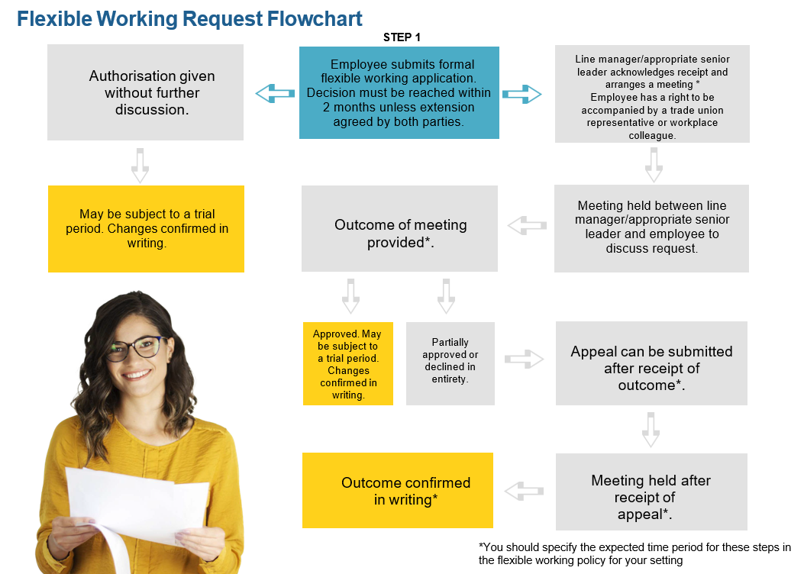

Step by step process for approving a flexible working request without further discussion
- Employee submits formal flexible working application.

- Decision must be reached within two months unless extension is agreed by both parties.

- Authorisation given without further discussion.

- May be subject to a trial period. Changes confirmed in writing.

Step by step process for approving a flexible working request if further discussion is needed
- Employee submits formal flexible working application.

- Decision must be reached within two months unless extension is agreed by both parties.

- Line manager or the appropriate senior leader acknowledges receipt and arranges a meeting within x working days [amend timeframe as appropriate according to your setting]. Employee has a right to be accompanied by a trade union representative or workplace colleague.

- Meeting held between line manager or appropriate senior leader and employee to discuss request.

- Outcome of meeting provided within x working days of meeting [amend timeframe as appropriate according to your setting].

- Approved. May be subject to a trial period. Changes confirmed in writing.

Step by step process for partially approving or declining a flexible working request
- Employee submits formal flexible working application.

- Decision must be reached within two months unless extension is agreed by both parties.

- Line manager or the appropriate senior leader acknowledges receipt and arranges a meeting within x working days [amend timeframe as appropriate according to your setting]. Employee has a right to be accompanied by a trade union representative or workplace colleague.

- Meeting held between line manager or the appropriate senior leader and employee to discuss request.

- Outcome of meeting provided within x working days of meeting [amend timeframe as appropriate according to your setting].

- Partially approved or declined in entirety.

- Appeal can be submitted within x working days of receipt of outcome [amend timeframe as appropriate according to your setting].

- Meeting held between line manager or the appropriate senior leader and employee to discuss request.

- Outcome confirmed in writing within x working days [amend timeframe as appropriate].

